Task 8 :

Jira Automation: Save Time without Admin Rights - 3 hour(s)
- What Can Be Automated in Jira by Non-Admins?
- Smart Checklists: Creating Reusable Checklists in Jira Issues
- Examples of Simple Automation Rules for Teams
- When to Ask Admins for Help with Jira Automation

What Can Be Automated in Jira by Non-Admins?
Automation is one of the most powerful features in jira software and we don’t need any jira admin to run it effectively. Even ithout admin we can automate repetitive tasks, enforce team rules, reduce manual updates and improve consistency. Every automation rule has :
Trigger : When something happens
Condition : Check if rule should run
Action : What jira does automatically
As a non admin, we can do following automations :
- Auto assign issues
- Auto update fields
- Auto add comments
- Auto notify users
- Auto label issues
- Auto link issues
- Auto transition issues
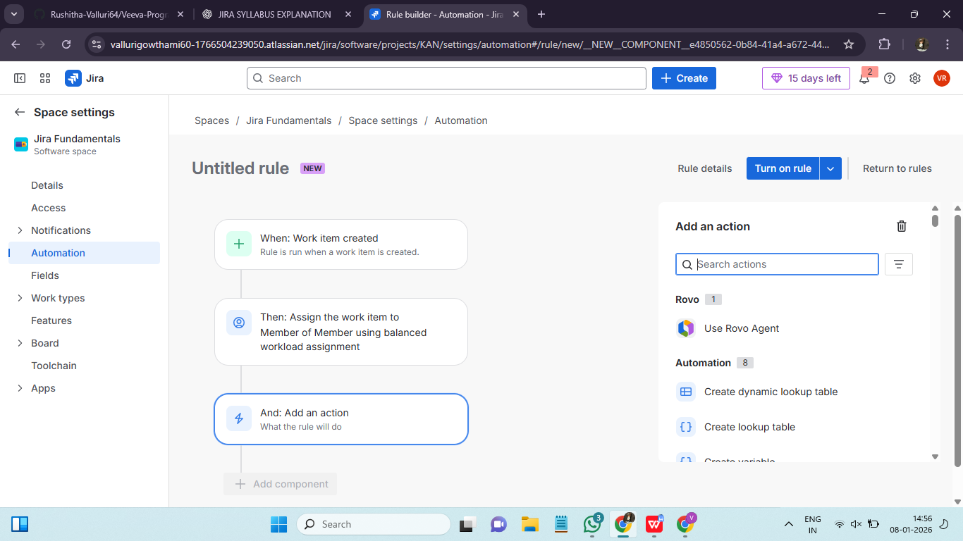

Smart Checklists: Creating Reusable Checklists in Jira Issues ::
A smart checklist is a reusable list of steps inside a jira issue that guides work conistently, reduces mistakes, can be auto created using automation and donot require admin access. Jira doesnot have native checklists by default. So jira uses these methods
- Description field
- Comments
- Automation + templates
A smart checklist use automation to auto insert a checklist when an issue created, an issue transtitions, an issue type is selected. It is called Smart because:
- It is automatic.
- It is consistent
- Doen’t require admin
- It is reusable
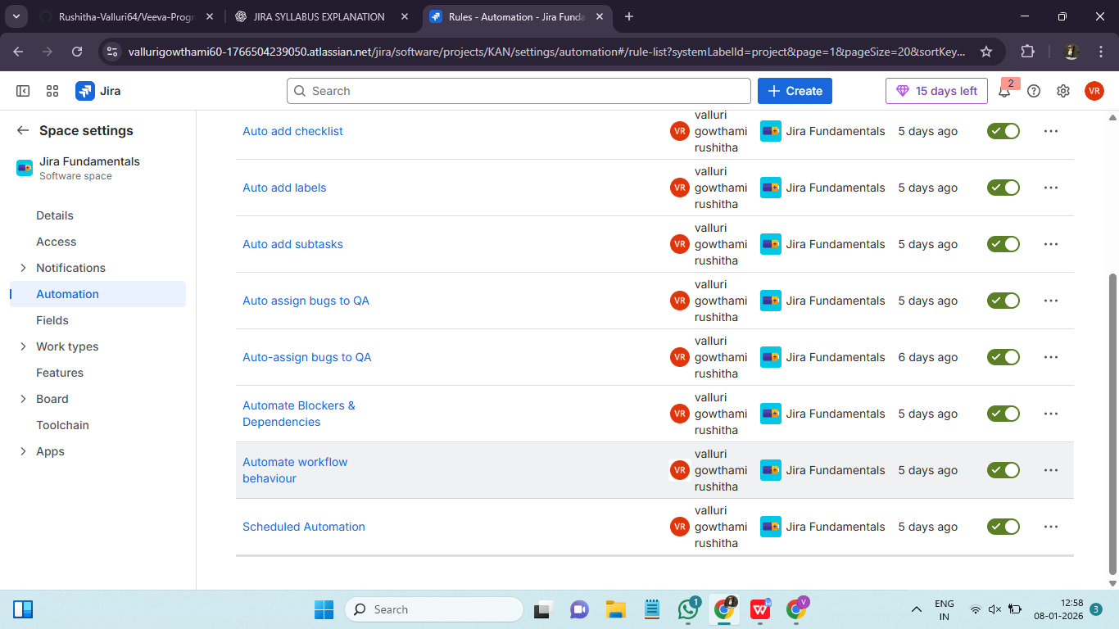

Examples of Simple Automation Rules for Teams ::
Automation rules are more powerful when they are simple, safe and repeatable. A simple automation rule solves one small problem, has 1 trigger, has 1-2 conditions and 1 clear action. Simple rules are easy to maintain and less risky. Every rule follows a pattern : When something happens, if conditions are met then jira does an action.
- Auto assign issues : New issues stay unassigned leads to delay.
- Auto label issues : Manual labels are inconsistent.
- Auto set resolution on done : Issues closed without resolution leads to bad reports.
- Auto add comments on blocked issues : Blockers are missed
- Auto create subtasks : Some subtasks are created repeatedly.
- Scheduled reminder :Overdue issues ignored.
- Auto transition on field update : Status not updated even when work starts.
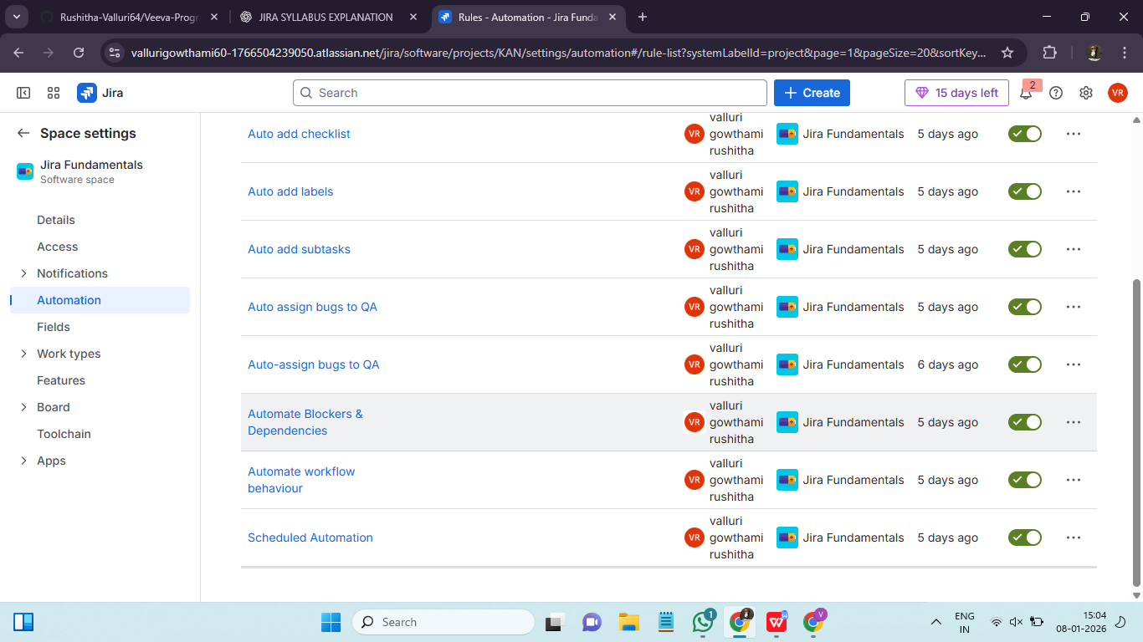

When to Ask Admins for Help with Jira Automation ::
Many users try to automate something that fails silently and time is wasted and admin gets pinged too late.
The following needs admin help:
- If automation needs to change jira structure or affect multiple projects.
- You don’t see the option you need.
- Rule works for some issues but not others.
- Create/edit workflows.
- Add validators/conditions.
- Add post functions.
- Create custom fields.
- Change status categories.
- When an issue happens and needs to create another issue in another project.
- Rule hits quota limit,
- Performance issues.
- Data & security related automation.

